1.) 1.Create a class Person with properties (name and age) with following features.

a. Default age of person should be 18;

b. A person object can be initialized with name and age;

c. Method to display name and age of person

class task {

    private String name;

    private int age;

    // Default constructor setting age to 18

    public task() {

        this.age = 18;

    }

    // Constructor to initialize name and age

    public task(String name, int age) {

        this.name = name;

        this.age = age;

    }

    // Method to display name and age

    public void display() {

        System.out.println("Name: " + name + ", Age: " + age);

    }

    public static void main(String[] args) {

        // Creating Person object with default age

        task person1 = new task();

        person1.display();

        // Creating Person object with specified name and age

        task person2 = new task("Alice", 25);

        person2.display();

    }

}

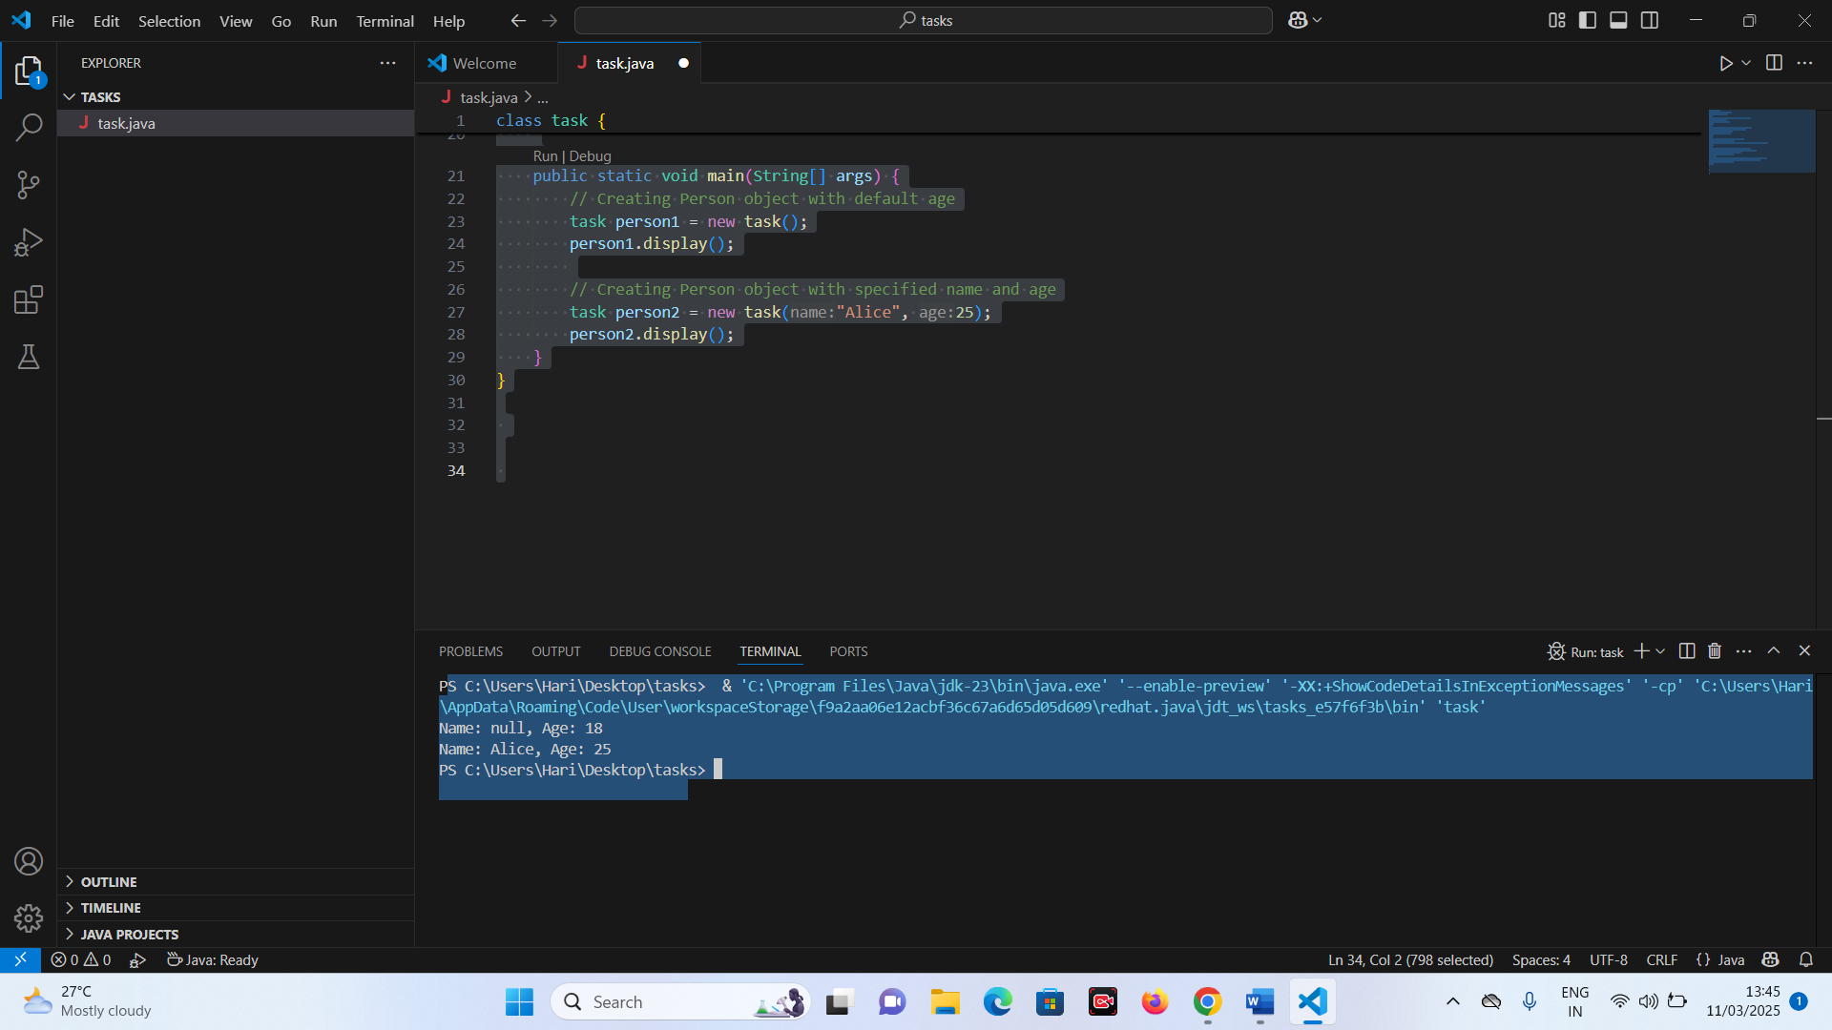

2.) 2.Create class Product (pid, price, quantity) with parameterized constructor.

Create a main function in different class (say ProductMain) and perform following task:

a. Accept five product information from user and store in an array

b. Find Pid of the product with the highest price.

c. Create method (with array of product's object as argument) in ProductMain class to calculate and return the total amount spent on all products. (amount spent on single product-price of product \* quantity of product